**Assignment 2- Driver Data Anaylsis**

Create database aastha_lab;

Use aastha_lab;

CREATE EXTERNAL TABLE drivers(driverId int,name varchar(30),ssn int,location varchar(50),certified char(1),wage_plan varchar(10))

ROW FORMAT DELIMITED FIELDS TERMINATED BY ',' location '/user/mavricbdhoct05/drivers';

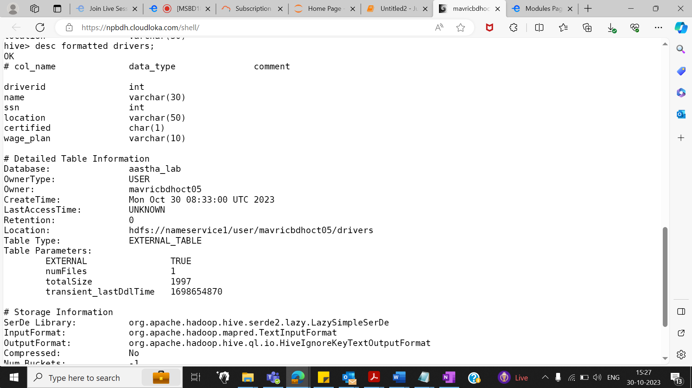

**

CREATE EXTERNAL TABLE timesheet(driverId int,week int,hours_logged int,miles_logged int)

ROW FORMAT DELIMITED FIELDS TERMINATED BY ',' location '/user/mavricbdhoct05/timesheet';

LOAD DATA LOCAL INPATH 'timesheet.csv' INTO TABLE timesheet;

**Q1. How many total hours and miles logged by each driver?**

**select driverId,sum(hours_logged) as total_hours, sum(miles_logged) as total_miles from timesheet group by driverId;**

**Q2. Print the name of the driver in the above query**

select driverId,name,sum(hours_logged) as total_hours, sum(miles_logged) as total_miles from drivers D join timesheet T on D.driverId = T.driverId group by D.driverId,name;

Q3. **Write the above query output in to hdfs directory**

vi test.sql

use Aastha_lab;

insert overwrite directory 'output' select driverId,name,sum(hours_logged) as total_hours, sum(miles_logged) as total_miles from drivers D join timesheet T on D.driverId = T.driverId group by D.driverId,name;

hive -f ‘test.sql’

hdfs dfs -ls

hdfs dfs -ls output

hdfs dfs -cat output/00000_0



